**Electromagnetic Braking**

**HW 6**

**Introduction**

Most of the braking systems that are in use today utilize the principles of friction to reduce the rotatory motion of a system. This type of braking system works by making contact with the object to apply brake on it which converts the kinetic energy to heat energy. But, In the long run this reduces the efficiency of the brake due to result of wear and tear that occurs every time the brake is in contact with the object. In order to replace this, an electromagnetic brake is introduced which works by application of a brake without any contact. This helps in providing a better long-term efficiency. It works by the principle of generation of eddy currents which induces a magnetic field that acts as a drag on the rotatory motion.

The EM brake is used in many of the modern-day braking systems such as in Roller coasters, Elevators and Railway systems. The Roller coaster systems use it as an emergency brake to stop the trains on the track at the end of the rides. Few [roller coasters](https://en.wikipedia.org/wiki/Roller_coaster) utilize the permanent magnets instead of electromagnets, in order to avoid the risk posed by potential [power outages](https://en.wikipedia.org/wiki/Power_outage), thus not requiring any power supply, however, loses the possibility to adjust the braking strength as easily as with electromagnets.

**Working Principle:**

The eddy brake contains a power supply, Electromagnet and an axle. The power supply is used to generate voltage or current into the Electromagnet. The Electromagnet is a device which generates a magnetic field (H) when a current is passed through it. The Electric field (E), induced due to change in magnetic flux and motional effects, along with the magnetic field induces eddy currents into the rotating objects when it is passed through it **[Sivasubramanian R, 2019]**.

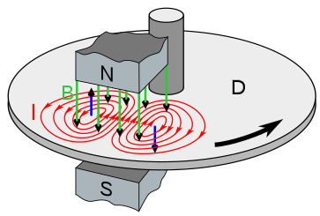

**Fig 1. Formation of Eddy currents (I) on a rotating disc (D) due to magnetic fields(B)**

**Analysis of the Torque generated against the rotational motion [K. Karakoc, 2015]**

We can use the Maxwell’s equation and Lorentz force to calculate the fields generated by the electromagnet and the Eddy current generated on the rotating object.

The Lorentz force is given as

**F = q (E + v x B) ( 1 )**

where **B = $μ$ H** and **D = $ϵ$ E** are the Magnetic flux and Electric flux densities respectively, **v** is the linear velocity of the conductor, **F** is the Lorentz force, **q** is the electric charge of the particle, $μ$ is the permeability of the medium and $ϵ$ is the permittivity of the medium.

Using this the eddy current density induced on the object is given by

**J = σ (E + v x B) ( 2 )**

The magnetic field and Electric field can be expressed in terms of the potential by the relation

$∇$**x A = B ( 3 )**

**E = $-∇ψ-\frac{∂A}{∂t}$ ( 4 )**

where **A** is the magnetic vector potential and $ψ$ is the Electric Scalar Potential

Now, the Maxwell’s equations are given as

$∇$**x H = J + $\left(\frac{∂D}{∂t}\right)$ ( 5 )**

$∇ . D=ρ$**( 6 )**

By substituting the above relevant relations in the above Maxwell’s equations, we get

**( 7 )**

**2 + = ( 8 )**

To solve the above equations a few assumptions are made as follows:

* The magnetic flux density is a uniformly distributed sinusoidal field with magnitude B0 and is applied perpendicular to the surface of the conductor

0sin () **k ( 9 )**

* The conductor is made of Aluminum, thus the electric permittivity ($ϵ$) and magnetic permeability ($μ$) is are assumed to be equal to that of free space.
* Since the magnetic field follows a sine curve the electric field will be a cosine curve and the magnetic potential is represented as a sine curve.
* Displacement currents are assumed to be negligible at low frequencies.
* Coulombs gauge condition ($∇ . A=0$) is adopted to obtain unique potentials as a solution to the above equations
* It is assumed that the current penetrates through the whole thickness(d) of the conductor which can simplify the problem to 2 dimensions. So, the Eq (2) can be revised as follows

**J = σd (E + v x B) ( 10 )**

The equations (7) & (8) can be simplified using these above assumptions as

**2 A = ( 11 )**

**2 ( 12 )**

Rearranging the terms in Eq (11), we get

**2 ( 13 )**

The time derivative of the magnetic vector potential can be calculated and is expressed as shown below:

$$\frac{∂A}{∂t}=\frac{ωAcos(ωt)}{sin⁡(ωt)}$$

Substituting the above equation in (13) gives an inhomogeneous Helmholtz Equation as shown below

**2 ( 14 )**

Where λ $=-μσd\frac{ωcos(ωt)}{sin⁡(ωt)}$, $$ϕ=μσd(-∇ψ +v×B)$$

The Eq (14) which can be solved to obtain a solution of A by using the boundary conditions for the given problem. Once we get the Magnetic vector potential, we can calculate the Eddy current density from the Maxwell-Ampere law as shown below

$$J=\frac{1}{μ}(∇×(∇×A))$$

We can use the above equation, Eq (15), to obtain the torque imparted by the eddy current and the fields by the relation

**Tb = ( 15 )**

This torque acts as a braking force which creates a drag around the axle that is connected to the rotating object such as a disk, thereby reducing its rotational velocity.

**Analysis of brake performance on different metals (M.Z. Baharom, 2007):**

We can graph a plot between the torque imparted and the current supplied to the electromagnet and the speed vs time characteristics to have a better understanding of how each parameter is affected during this process. By comparing the results of these graphs for each type of material that can be used for the rotating objects, we can find out the best material for the rotating object that can be used an efficient electromagnetic braking

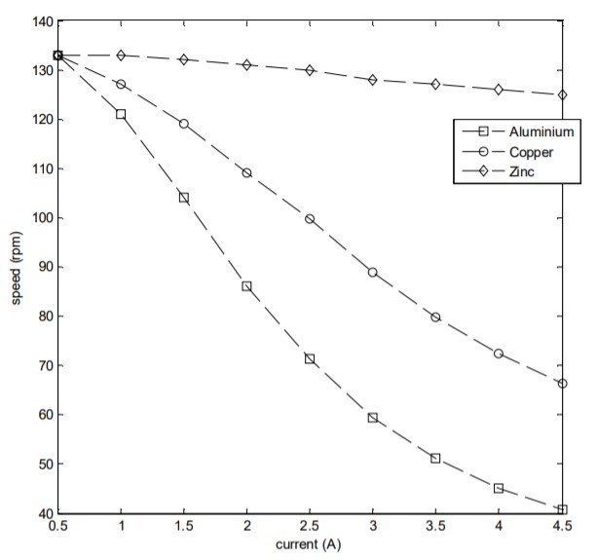

**Fig 2. Speed vs current for different materials**

Based on the values obtained in the graph, aluminum is shown to be the best material when compared with copper and zinc, for braking purposes. This performance can be further improved by using aluminum alloys such as AL6061. Thicker disks will generate more torque, as seen in Eq (10), by inducing higher Eddy current density which will oppose the objects rotational torque in order to reduce the velocity of the object. Materials with higher electrical conductivity will generate high torque against the motor torque itself in order to stop the disc.

**Application of EM braking in Roller Coasters:**

The roller coaster utilizes the energy conversion as the train moves around the loops and curves of the track. This energy conversion is also utilized for braking purposes in the roller coasters. At the end of the ride, the train must be slowed down and brought to a stop in the station. There are two types of Eddy current brakes, linear and disk type. A linear type of Eddy current brake is used in the roller coaster systems as a braking device. This type of Eddy current brake does not dissipate as much of heat as the other types of Eddy current brakes as the rotating object passes be only once during the braking process. The simplest linear, eddy-current brakes have two components, one of which is stationary while the other moves past it in a straight line.

**Fig 3. EM Braking used on the track of a Roller Coaster**

The EM brake used in the roller coaster uses the track itself as a static part of the braking system. In this, few Electromagnets are mounted at the end of the track, which produce eddy currents in pieces of the metal mounted on the side of the cars as they pass by them according the relation given by Eq (10). The usage of Electromagnet instead of a permanent magnet allows the braking force to be varied. The kinetic energy of the moving vehicle is converted to heat energy by the eddy current flowing through rail, which leads to warming of the rail. This is done by generating a braking torque due to Eddy current on the wheels of the trains, according to Eq (15). The eddy current brake does not have any mechanical contact with the rail; thus, no wear and noise are created during the braking. The faster the train, the stronger the currents induced, and the stronger is the braking force applied on the wheels due to the torque.

 The train move freely along the track until they reach the very end of the ride, where the magnets meet the metal and the brakes kick in. This kind of braking is also used as an emergency brake at high speeds for other applications.

**Conclusion:**

In the recent years, this system of braking is regarded as one of the ideal braking approaches since it is quiet, frictionless, requires less maintenance and can be used an emergency brake. This is currently used in roller coaster rides, to regulate the speed of the rides, as they require a secure braking system for safety of everyone on board. Similarly, they can also be used in high speed trains and industry purposes. The only problem with this type of braking is that it slows down the rotational speed but doesn’t effectively stop them. So, to overcome this problem, a friction break is often used in conjunction with this break to create a near perfect braking system.

**References**

[1] K. Karakoc et al., Analytical modeling of eddy current brakes with the application of time varying magnetic fields, Applied Mathematical Modelling (2015).

[2] M.Z. Baharom, M.Z. Nuawi, G. Priyandoko, S.M. Harris, ’Electromagnetic Braking System using Eddy current for brake disc of Al6061 and AI7075’, International Review of Mechanical Engineering.

[3] [Eddy-current braking: a long road to success](https://www.railwaygazette.com/news/single-view/view/eddy-current-braking-a-long-road-to-success.html) by Jennifer Schykowski. Railway Gazette, 2 June 2008.

[4] Sivasubramanian R, Siva sundar S, Umakhesan A, Rajavel M, Saravanan M, ‘Design and Development of Electromagnetic Braking System’, International Journal of Innovative Technology and Exploring Engineering (IJITEE), Volume-8 Issue-4S, February 2019.

[5] Smit Patel, Meet Patel, Anand Patel, Chetan Sanghani, ‘Development of the Electro-Magnetic Brake’, IJIRST –International Journal for Innovative Research in Science & Technology| Volume 1 | Issue 12 | May 2015.

[6] Ann-Marie Pendrill, Magnus Karlsteen, Henrik Rödjegȧrd, ‘Stopping a Roller Coaster Train’.

[7] [H.D. Wiederick](https://www.researchgate.net/scientific-contributions/2137028208_Harvey_D_Wiederick), [N. Gauthier](https://www.researchgate.net/profile/Noel_Gauthier), [D.A. Campbell](https://www.researchgate.net/scientific-contributions/2025314153_Dwight_A_Campbell), [P. Rochon](https://www.researchgate.net/profile/Paul_Rochon), ‘Magnetic braking: Simple theory and experiment’, American Journal of Physics, Vol 55, No. 6, June 1987.